Inverter User Instructions and circuit operation.
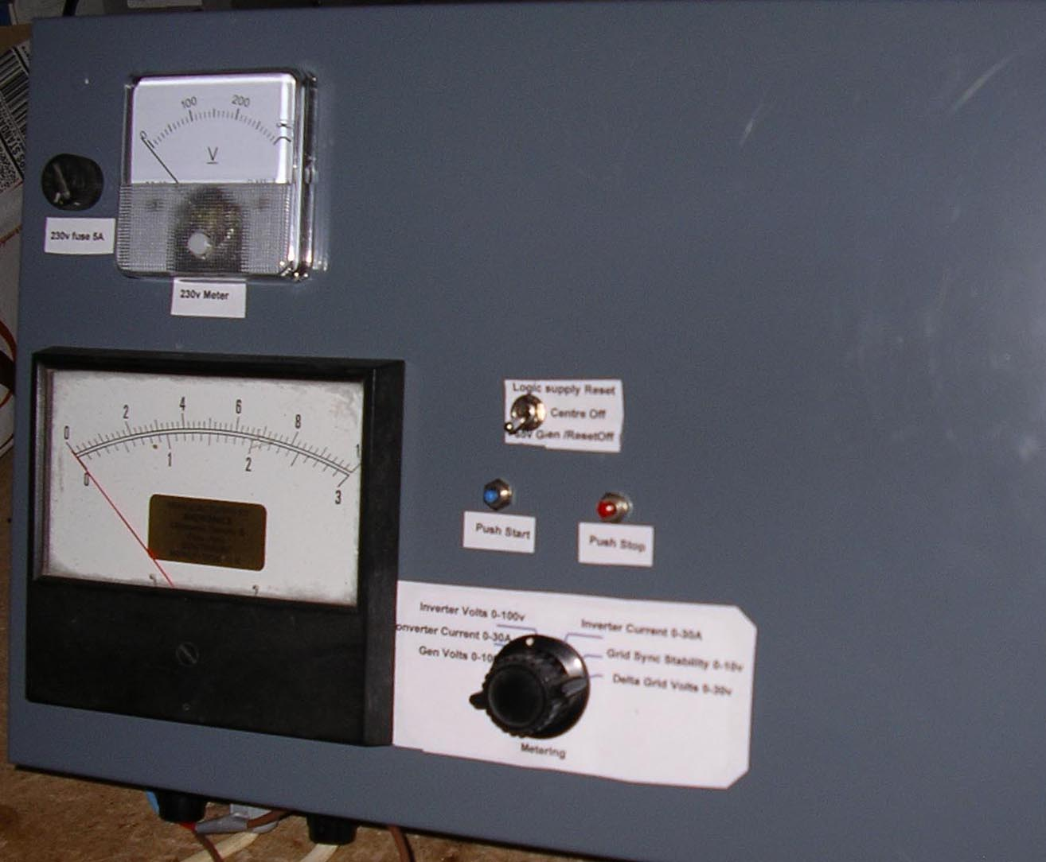

Metering:

A rotary switch is fitted for meter monitoring:

Pos 1: Wind generator supply voltage, 100v fsd
Pos 2: Converter Driver current 0-30 amp fsd.
Pos 3: Inverter input voltage, 100v fsd.
Pos 4: Inverter current load, 30 amp fsd.
Pos 5: Grid sync stability, 10v fsd
Pos 6: Inverter/Grid current, 3 amp fsd

In addition a separate 230v meter permanently monitors the ac output.

Switches.

1) Reset for protection circuits.

Protection.

Any of the following conditions will cause a power shutdown:

a) Inverter/wind gen over voltage > 65v occurs, (manual Reset Up then off)
b) Gen under voltage < 18 v occurs, (auto reset when>20v)
c) Converter Fet > 30 amps peak (Q22 disables converter). (manual Reset Up then off).
d) Either push/pull Q25/26 inverter drive transistors > 24 amps (Start Button to restart)
e) If either 50hz half sine fails manual reset Down for Power off.(Circuit failure)
f) Grid tie current > 3A disconnects load (auto reset when current reduced)
g) A 5 amp fuse is fitted in the 230 volt circuit.

Start & Run Operations.

Assumes the generator is delivering between 18 and 56 volts, Inverter input metering shows supply available with cooling fan operating and a low level 230v load or grid tie is present with the correct loading :

a) Press the inverter 'Start' button to generate 230v 50hz.
b) Switch on the 230v 50 hz none grid tie loads according to the generator load curve.
c) Press the inverter 'Stop' button to switch off the 230v only.

Note: Below 20watt load will cause 230v meter to read high

Regulation normally maintains a constant 230v 50 hz output by monitoring the inverter output on a none grid tie load. Grid tie loading is regulated by generator supply availability.

Grid Tie Loading

Grid tie is automatically enabled when 230v 50hz is connected. The neutral of the grid is connected to the neutral of the inverter output internally therefor it is imperative that 230v 50hz Line and Neutral are correctly wired.

Connecting the 230v grid supply will automatically sync the logic in both the 'Stop' (no inverter output being generated) and 'Start' mode. It take about 30 seconds for full syncing to occur & Meter position 5 should then be stable. When the 'Start' button is pressed sync could be lost momentarily due to voltage variations so the final tie connection is made when sync is stable.

When sync'd, a volt free relay makes contact closure which is used to enable dual scr switching grid mains linking circuit. If sync is lost while feeding power, or the generator voltage falls below 18v the grid linking scr's are disabled to isolate the inverter output from the load. Meter position 6 measures the grid tie current, scale 3 amps.

With a grid tie load, the output power is delivered using current feedback to control the power according to the generated voltage available. The 50Hz output current will increase if the wind generator voltage increases and reduce if the voltage reduces, 18v to 56v with 0.25 amps to 3 amps. The voltage generated by the Inverter is available at the none grid tie load output socket which is not monitored by the grid tie current meter.

The grid tie loading will be adjusted according to the following table:

None Grid Tie Loading Notes (230v input to inverter is disconnected)

1) When the inverter is put on load at say 15 mph wind speed, then the load can be 220 watts with a 55v terminal voltage according to the generator power curve. Below 15mph the converter has been providing a regulated 230v out for lower loading capacity.

At 50v generator input, the converter has no need to boost the voltage for the inverter which will automatically stop regulating a constant 230v output voltage.

If the wind now increases to 20 mph and the load is still 220 watts then the output generator voltage will increase beyond 50v because there is no extra loading to soak up the excess power. Failure to limit the generator voltage by adding extra loads will ultimately cause activation of the 65 volt circuit limit shut off requiring a manual reset.

2) At high wind speeds the load can be high, say up to 1kw. If a large proportion of this load is on the inverter, then as the wind decreases the generator voltage will sag unless the 230v load is reduced. Assuming a load reduction does not happen in an orderly fashion then the converter output will try to increase the inverter input voltage as the generator voltage reduces in order to maintain the 230v output.

Because the load is still too high, the inverter may eventually go into 'low voltage' condition and shut off the inverter so that a manual reset has to be applied. If the shut off does not occur, the converter output may reach an excessive current condition causing damage. (At 25v a 750w load represents 30 amps in the converter). A 30 amp converter protection circuit is incorporated to limit the converter output if this occurs. This requires a manual reset.

Wind Turbine Performance Data Turbine Model = FE1048U (408 PMG) Turbine Blades = 5 (25 deg blade pitch) Battery Load = 48 V Startup Wind Speed = 2.0m/s Charging Initiation Wind Speed = 3.8m/s Charging Initiation RPM = 380
Wind (m/s) | Wind (mph) | Turbine RPM | Output Current (A) | Battery Voltage (V) | Power (W) | Power/Day
3.8 | 8.6 | 380 | 0.8 | 52.0 | 42 | 998
4.5 | 10.1 | 400 | 1.4 | 53.0 | 74 | 1781
5.6 | 12.6 | 420 | 2.6 | 54.0 | 140 | 3370
6.5 | 14.6 | 465 | 4.0 | 55.0 | 220 | 5280
8.0 | 18.0 | 480 | 7.4 | 56.0 | 414 | 9946
9.0 | 20.3 | 490 | 10.4 | 56.2 | 584 | 14028
10.0 | 22.5 | 510 | 14.0 | 56.3 | 788 | 18917
11.0 | 24.8 | 520 | 16.5 | 56.4 | 932 | 22357
12.5 | 28.1 | 540 | 20.0 | 56.6 | 1132 | 27168
14.0 | 31.5 | 610 | 26.0 | 56.6 | 1472 | 35318

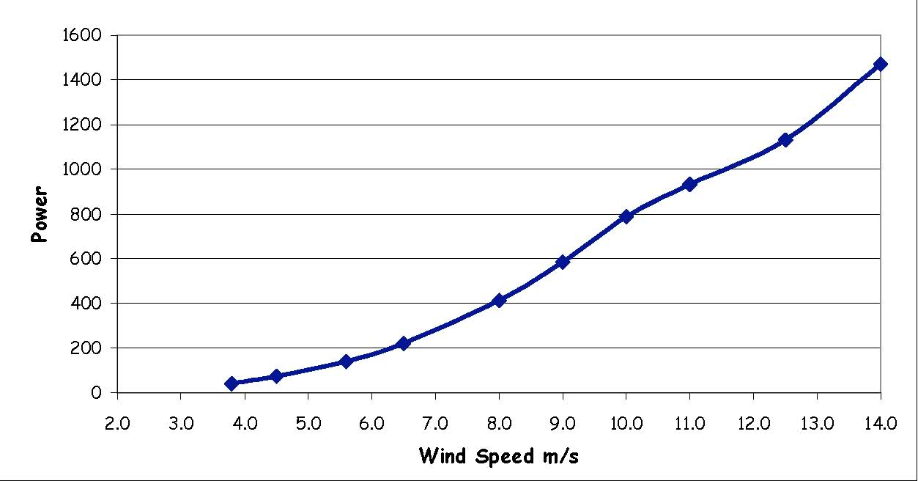

Circuit Description.

1)Supply Control

The generator supply is passed via the converter boost inductance to Q14. Q14 acts as a source follower to limit the generator voltage so that the 12 volt regulator maximum input voltage will not be exceeded. Q14 gate is limited to 35 volts by D10 so the source will be kept below 40v. Q14 has to be mounted on a heat sink to limit chip temperature when input voltages rise beyond about 50v. The cooling fan supply is taken from Q14 source to reduce the 12v regulator loading.

When the generator input exceeds 18v, D18 conducts to turn on Q13 causing RL2 to operate and connect the supply through to the 12v and 5v regulators supplying the logic circuitry. Generator voltage in excess of 55v will cause the scr Q12 to switch on and cause RL2 to de energise. A manual reset switch will ground Q12 and allow the power to be re applied. Automatic reset is not provided since the generator off load voltage could be well beyond the point where the circuit components could fail, therefor a load dumping scheme above 65v must be in the system to prevent generator over voltage damage.

In case of 12v regulator failure whereby the output of Q14 would overdrive the logic circuits, D13 zener will trigger Q12 to remove the supply from the logic circuitry.

2) Logic Circuits.

IC3 a & b operate as a 25.6K hz clock oscillator to feed the converter pulse width modulator IC14. Initially, control of the converter output is via feedback amplifier IC13 with C24 being uncharged causing the pulse width modulator to be in minimum pulse width condition providing no boost for the incoming voltage. As C24 charges, feedback via RV8 becomes active and reduces Q21 conduction causing the pulse width to increase. This boosts the converter output to its initial setting of 34 volts. If the generator input is above this level then no boost is provided. Further boost will only be activated when the inverter is generating 230v 50hz and the voltage regulation demands it.

The inverter was initially designed for a pure sine wave 230v 50 hz output and to achieve this the inverter driver requires pulse width modulated signals to be transformed from the DC generator voltage to 230v ac. The modulator takes 100 hz from the IC4 binary divider and integrates this into a triangle wave to feed IC5a. The output of IC5a drives the pulse width generator Q1with IC3 c & d providing a half sine wave pulse width modulated 12v signals via IC2 to the inverter push pull transformer primary driver sources Q2, Q3, Q4 & Q5.

These signals are alternately gated to ensure that equal and opposite magnetising currents are supplied to the transformer in order to prevent flux walking in the core. Thus the core flux will always be the same in each direction and will not reach a large flux offset which would cause core saturation. The gating signals are derived from the clock divider running at half the clock frequency, ie 12.5kHz.

IC4 binary also provides 50hz commutation signals for the inverter secondary required to reconstitute the two half sine waves. IC6 c & d act as a 78usec delay circuit so that the inverter secondary commutation switching cannot be activated before Q27 or Q28 are fully off. Without this it would be possible for both Q27 & Q28 to be conducting at the same time placing a short circuit across the inverter secondary. These signals are also used to enable the grid tie Scr triggering circuits when grid tie synch is being used.

The grid tie synchronising circuit IC11 is also supplied with 50hz which together with a grid 50hz transformer isolated reference signal feeds the phase comparitor latch IC17 c & d. Due to the isolation transformer winding resistance and inductance effects, a correction capacitor may be required to adjust the phase delay at the transformer output so that the input and output phase shift is zero degrees. The phase comparitor latch feeds its 1:1 signal via IC11a to Q3. Any phase error will then cause the 25.6khz clock generator to adjust its frequency and reduce the 50hz phase shift to zero. When zero phase shift is achieved RL3 will energise and the grid tie Scr's trigger circuit will be supplied with 12v.

The start/stop latch IC1 a & b enables/disables the inverter drive signals and provides zero crossover switching for the 50hz inverter generated output. This latch will be put in the stop condition by the action of RL1 or the stop push button.

RL1 can be activated by several conditions. These are either over voltage or under voltage inputs, too high inverter drive current via IC5b and loss of either half sine output waves monitored by IC9 & IC10.

Output Circuits.

The inverter push pull drive MOS Fets Q25 & Q26 experience high inductive transformer switching transients when turn off occurs. This requires snubbing circuits to prevent the high overshoot transient from exceeding the breakdown voltage of the device. To limit this, each switch has a C R series network to absorb some of the transient's energy. In addition D36 & D37 TVS clamp diodes will limit the voltage spikes to 133v maximum. Such transients also occur across the secondary and these are limited by the clipping action of D38 & D39 to about 440v.

To generate a sine wave at the output, each primary driver is fed with a half sine pulse width modulated square waves. The pulses are alternated to each driver, this to prevent the core flux from becoming saturated by driving the flux more in one direction than its opposite. The transformer outputs are then full wave rectified, each producing a transformed pulse width modulated output, one a positive voltages & one negative voltages and each with pulse values exceeding 340v, representing the half sine waves prior to filtering. Q27 & Q28 are alternately commutated on and off by IC7 & IC8 at 50hz resulting in the peak to peak pulse width voltages of some 680 volts. The fast rectifiers have a blocking voltage specified at 1000v as do the commutating Mos fets.

Inductive & capacitive filtering remove the 25.6khz components resulting in the familiar 50hz 230v rms (340v peak) pure sine wave. Each half sine wave is monitored by IC9 & IC10 as a precaution against Mos Fet failure. Amplitude of the inverter output is sampled via an optical coupling which is used to regulate the output voltage via R53 and IC13b. To ensure a low output voltage at start, a charged capacitor is positioned in the feedback loop which limits the immediate demand for voltage by the regulation circuit. As the capacitor discharges, the regulation circuit takes over until feedback balance is achieved.

Grid Tie operations

Synchronising to the grid 50hz can occur before the output power is delivered because of the presence of each 50hz phase comparitor signal at IC17b and RL3 becoming energised. The grid tie Scr's will continue to block until the start latch is enabled. With the start latch enabled and on sync with 50hz grid, RL3 enables commutate signals to the tie scr's by allowing two oscillators to feed pulse transformer outputs to the gates of the Scr's. If Inverter 230v output is greater than grid 230v then tie scr's will operate and supply current, if not then tie scr's will block. This ensures that the current flow will always be from source to grid. The current is monitored by a current transformer in series with the grid load.

Regulation of grid current flow is controlled by monitoring the Generator input voltage. At 20volts the current is limited to 0.18 amps(40W), and at this level the current feedback is insufficient to override the none grid tie load voltage control circuit and the current regulation signal is ineffective.

As the Generator voltage increases, the demand overrides the none tie regulation and causes the converter output to increase via IC13b thus forcing the inverter 230v to rise. This extra voltage forces a larger ac current from the inverter in to the grid until the current feedback signal balances with the increase in generator voltage. Further increase in generator voltage causes more current to be supplied to the grid up to about 2 amps cut off which then inhibits the scr triggers.

A 33 ohm NTC thermistor is in series with the output which causes the inverter 230v output to be about 10v greater than the grid voltage at low currents. This reduces due to self heating of the thermistor as current is increased. At 170 deg C the thermistor will reduce to about 1 ohm with 2-3 amps flowing. Ultimately there will reach a point where no matter what the demand for extra current is this will be self limiting as a function of the source impedance of the system. This has not been evaluated.

Construction notes.

Before starting the PCB assembly note the positions of the power semiconductors and construct adequate heat sinks. Three sinks will be required which can be made from aluminium sheet and narrow channel fins riveted to the sheet. The sink for the inverter transformer primary & secondary Mos Fets and rectifier diodes is from a 6.5" x 2" single sheet with a right angle bend at 4". Position the diodes & transistors loosely on the PCB and mark the assembly screw holes ready for drilling. Pop rivet the cooling fins as required on the side away from the transformer mounting position. A similar arrangement for the 12 volt regulator and Q 14 heat sink can be constructed. The converter driver Q20 & diode D16 were mounted on a conventional but modified heat sink. Spray paint the heat sinks black to aid the heat radiation and remember to use semiconductor isolation pads and sleeves when mounting permanently.

The converter inductor is 0.68 mH hand wound on a 750 u ferrite E core of csa 1.25sq cm, 14 swg enamelled copper wire was used. Confirm the value using a resonant circuit and oscilloscope or inductance meter.

The inverter transformer primaries were bifilar wound to ensure balanced push pull operation on a EPCOS E55 core former using 18 swg. Heavier gauge wire will reduce the power losses. Main secondary windings can be wound from 24 swg depending on form factor, again power losses dictate final output power levels. Secondary layers need to be insulated using adhesive tape or paper to avoid insulation breakdown. Two small secondary windings for the commutation drivers IC7/8 are separately insulated wound on last.

The 230v filter inductance's were wound on ferrite toroidal cores to the values indicated with a csa of 1.25 cm. Obviously these values were chosen to remove the 25.6khz wave component from the 50 hz output.

The current regulation transformer is a bog standard 50hz 115v+115v primary 6v out secondary 3va or 6va on a laminated iron core. The laminations were dismantled and the secondary stripped off. The secondary space was filled with 22 swg wire, 20 or 30 turns and this now becomes the primary in series with the grid tie loading. The original 115v+115v primary provides the current monitoring feedback signal for the grid tie regulation. The rectified output was verified using lamps as loads and plotted 0 to 6v at 1 amp primary current.

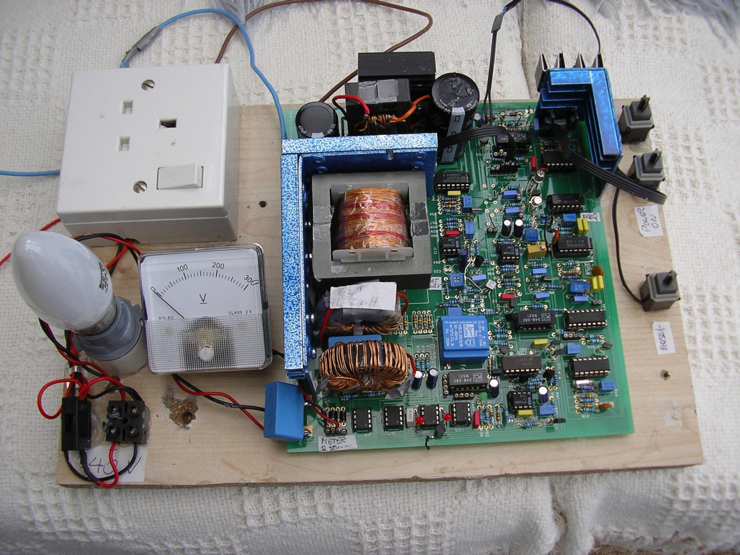
Author: Max Cottrell
max@mcottrell.co.uk

